Diamond Dynamics Thruster
- 70$ each
- Would need some modification to shrouds
- Props can easily be redesigned for efficiency
- Using 8 motors will give us 6 DOF
Most of the thrusters operate at an average of 12V and 200W. And around 16-18 Amps. Per thruster. It’s looking like we will only need 4 for our application. Most teams decide on 4, I’ve seen a few use 6, and only 1 use 8.
4 propellers (2 flat horizontal, 2 angled vertical) provide forward and backward motion, vertical motion, yaw control and roll control. I think this is sufficient, because we do not have to move left and right without turning, and because pitch control is only relevant if our ROV is not structurally balanced. In the case that the rov would have trouble tipping over from some sort of weight that it picks up, we might need pitch control. But I don’t think we do, since so many teams don’t have?

https://seamate.org/collections/barracuda-rov/products/four-thruster-kit

more powerful bilge pump

Cost Estimate per Thruster
Power Requirements (Voltage, Current, Power) Per Thruster
Generally: 240 watts of power at 12 volts while operating per thruster

Number

Configuration and Degrees of Freedom Provided
- Vertical Movement Thrusters for smooth maneuverability (these 2 vertical mortars can be angled to provide roll control to offset any current inflicted issues)
- Two Horizontal Thrusters, providing both forward/backward motion, and yaw

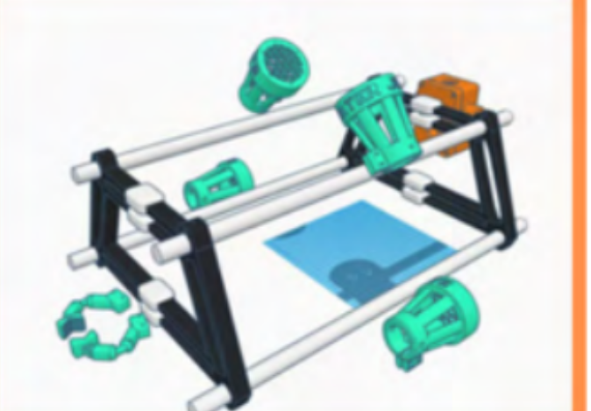
Thruster Vectored Configuration
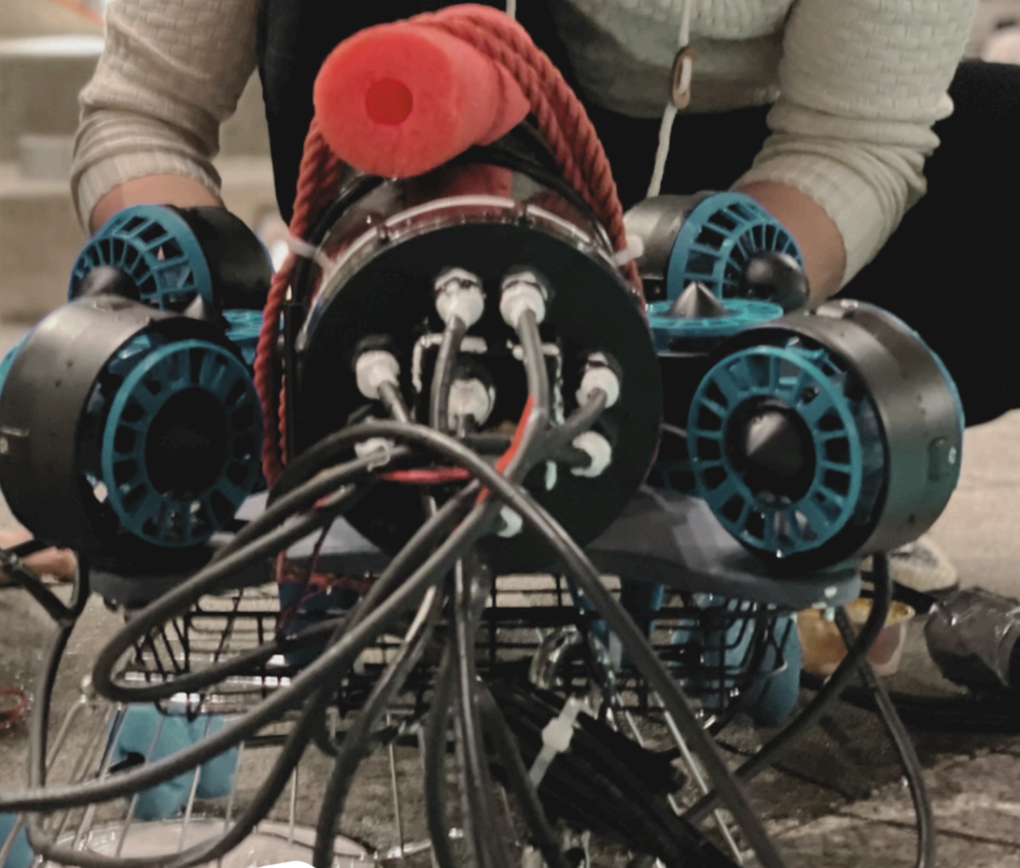
6 Thrusters, T-200 Configuration

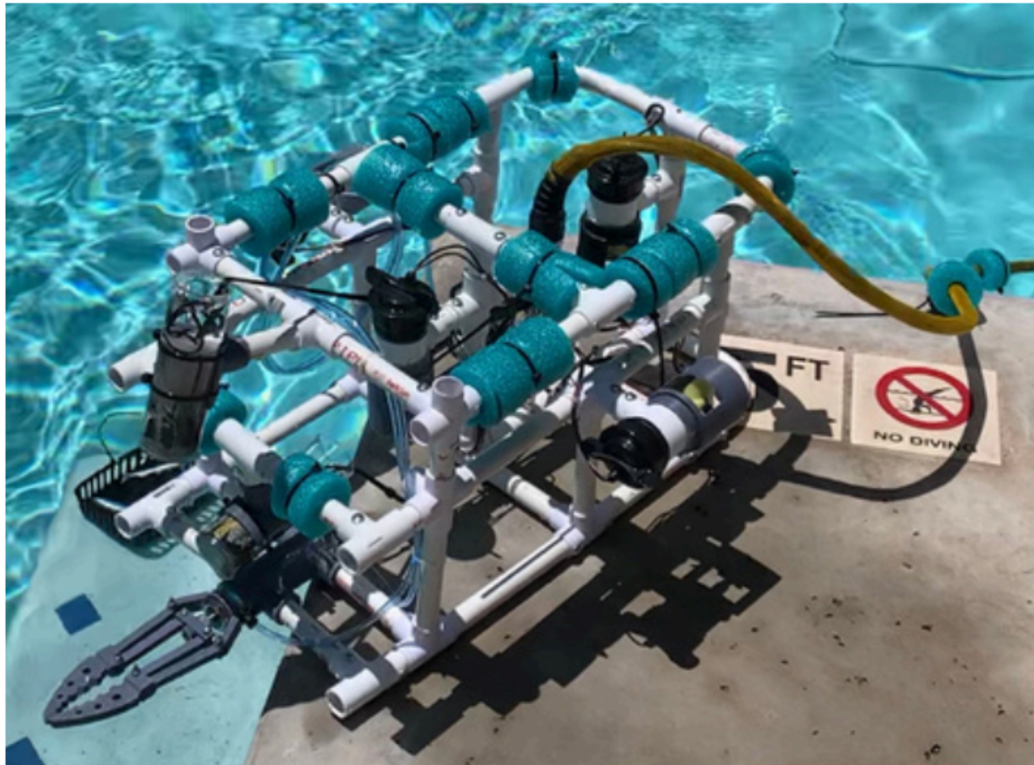

4 Thrusters, T-200, Bilge Pump Conversion
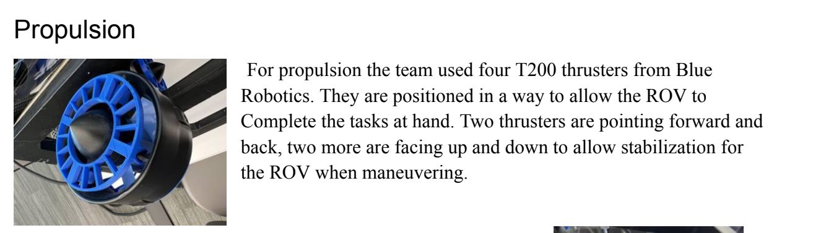
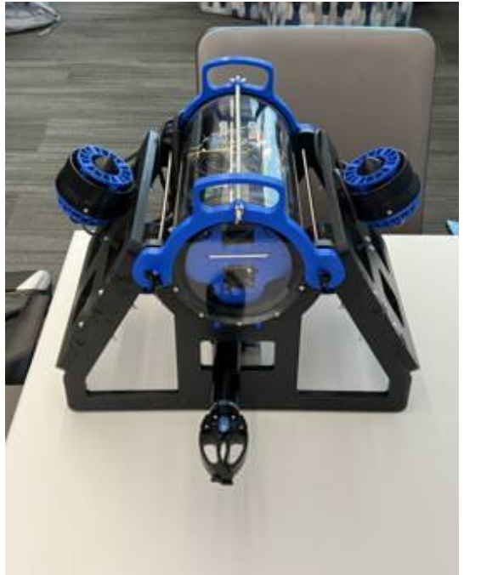
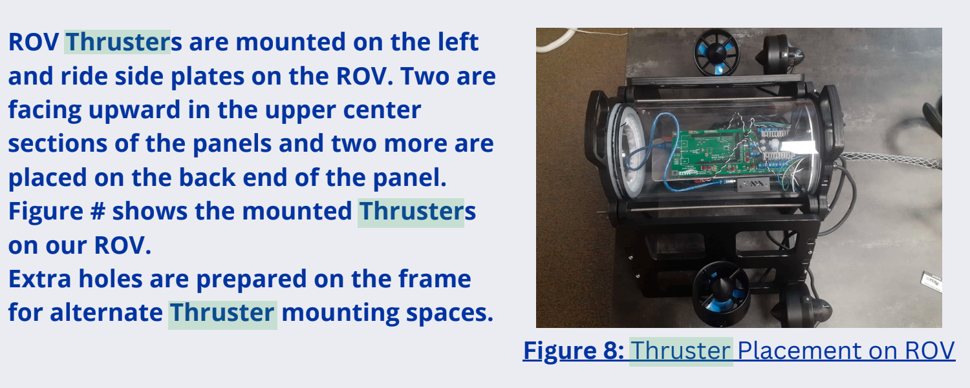
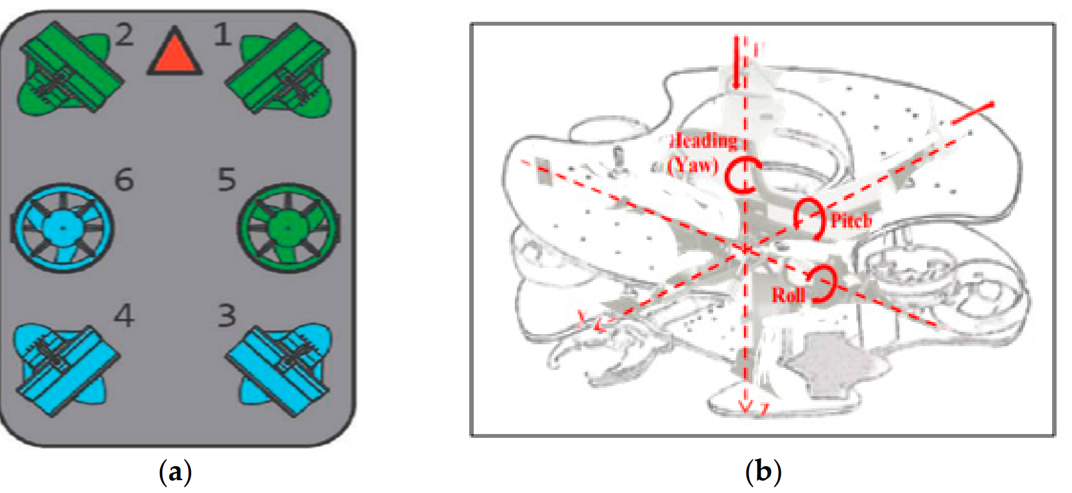

NOTE: A very popular configuration is the two operating horizontally and then two angled vertically to provide both vertical movement and roll control. This is just a little worrying because it does not exactly address pitch control provided from an instability while manipulating objects.

Requirements Satisfied

